MODULE 1
- Explain the objective of management.

Objectives of Management:

1) Optimize Resources:
- Management teams work to use resources effectively to provide the most output possible. This objective creates the ability to increase profits by reducing the ratio of resource costs to profits.
- Management teams implement logistic strategies and procedures to identify and reduce processes that create waste and require extra resources.

2) Increase efficiency:
- Increasing the efficiency of operations, production and services allows for greater production, sales and profits.
- Management systems track the processes, duration and flow of the workplace to determine methods that provide more efficient outcomes.
- Managers may work with other employees and department leaders to create and implement new processes and requirements.

3) Maximize profits:
- Management teams aim to find the balance between maximizing profits and promoting a beneficial workplace for employees.
- Maximizing profits includes working with various departments and leaders such as accountants, supervisors and executives to determine areas that require improvements and changes.
- Managers can achieve maximum profit objectives by identifying unnecessary expenses and waste and creating new procedures for more efficient operations.

4) Promote personal development:
- An effective management team prioritizes the growth and development of its employees.
- Providing opportunities such as seminars, mentorship programs, training resources and internal promotions allows employees to develop new skills and advance their careers.
- The personal development and growth of employees can also contribute to the growth, quality and efficiency of work produced and can help management achieve multiple objectives simultaneously.

5) Maintain quality:
- Management teams handle the regulations, procedures and parameters for the production and distribution of products and services.
- A primary objective of management includes maintaining the quality standards necessary for the organization.
- The team collaborates with other departments, supervisors and employees to create, implement and maintain quality.

6) Uphold workplace morale:
- The environment, attitudes and morale of an organization can affect the overall production and profits.
- Positive morale among employees creates intrinsic motivation for employees to complete tasks and contribute greater effort.
- Management teams work to uphold morale by implementing effective authority structures, creating incentive programs and responding to employee feedback.
- Valuing employees and ensuring positive relations increases morale and motivates individuals to continue to grow.

7) Reduce risk:
- Many management positions focus on forecasting and projecting results and changes.
- One main objective for managers includes using planning and predictions to reduce opportunities for risks and losses.
- Reducing risk factors such as safety issues, wasted resources and extra expenses can help increase profits and eliminate loss.

8) Generate business strategies:
- Management teams often use higher-level critical thinking and abstract strategy to improve operations and profits.
- The team collaborates with executives, leaders and stakeholders to generate, pitch and implement overall business strategies or frameworks.
- Creating an effective and consistent business strategy can help identify and narrow objectives for all employees to reach a common goal.

9) Coordinate workflows:
- The workflow and internal structure of an organization can influence productivity and efficiency.
- Management teams may include or work with logistics, engineering and production professionals to develop logical and expedited workflows, internal structures and facility designs.
- Managers may also utilize tools such as organization charts, flow diagrams and procedure audits to evaluate and communicate workflow operations.

10) Identify talent:
- An organization's management aims to identify, acquire and maintain top candidates and employees.
- Managers may work with recruiters to establish hiring requirements, evaluate candidates and create recruitment offers.
- Identifying and gaining talented and qualified employees increases the knowledge, expertise and production of the organization as a whole.

11) Ensure availability:
- Management teams work to handle, maintain and predict the availability of resources, goods and services.
- To achieve this objective, managers may project and forecast the needs of the organization or public and monitor issues such as shortages.
- Predicting and handling issues allows the management team to plan and implement changes to prevent production and distribution delays.

- Discuss the functions of management according to Luther Gulick.
POSDCORB is a broader concept of management functions (Luther Gulick).

P – Planning – Setting objectives and deciding actions.
O – Organizing – Structuring work and resources.
S – Staffing – Hiring and developing employees.
D – Directing – Leading and supervising employees.
CO – Coordinating – Integrating activities of different departments.
R – Reporting – Informing superiors about progress through reports and records.
B – Budgeting – Managing finances, accounting, and financial planning.

The Seven Elements of POSDCORB
- Planning: Working out in broad outline the things to be done and the methods for implementation.
- Organizing: Establishing the formal structure of authority to define and coordinate work subdivisions.
- Staffing: The personnel function of training, maintaining favorable work conditions, and bringing in staff.
- Directing: Continuous decision-making and issuing specific orders/instructions as a leader.
- Coordinating: Interrelating the various parts of the work and organization.
- Reporting: Keeping superiors and subordinates informed through records, research, and inspection.
- Budgeting: Fiscal planning, accounting, and control

- Explain the nature of management.

To understand the nature of management, the following aspects of management need to be understood.

- What is management/ is it a science?
- Is it an art?
- Is it multidisciplinary in nature/ is it a profession?

Management as a Science:
- Frederick Winslow Taylor was the first manager-theorist to apply scientific principles in the field of management.
- He attempted to find out the one best way of doing a task scientifically by observing, analyzing, and experimenting.
- With his knowledge and experience at a steel manufacturing company, he came up with a few scientific principles in management.
- Following the lead from F.W. Taylor, his followers, such as Frank and Lilian Gilberth, developed few more scientific ways in management.
- Management is a social science and deals with human beings who are very complex, unlike inanimate things such as light or heat.

Management as an Art:
- Under science, one learns the 'why' of a phenomenon, but under art, one learns the 'how of a phenomenon.
- Art is mainly concerned with bringing the desired result with the application of skills.
- To get things done.
- Management discipline has both science and art components; it is both science and art.
- Science and art are not mutually exclusive; actually, they are complementary to each other

Management as a Profession:
- According to McFarland, a profession should have specialized knowledge, principles, and skills.
- A profession should have methods of acquiring training and experience. It should have formal ethical codes that guide the people practicing the profession.
- A professional practicing a profession charges fee for the services he/she provides to their clients.
- Unlike medicine or law, management is not a prerequisite for anyone to become managers.
- Even though management has few features to become a profession as of now, management has not achieved the status of a profession.

- Define Management and Administration. List out the difference between these two.

Management:
- Management refers to the process of planning, organising, staffing, directing and controlling the activities of an organisation to achieve its goals efficiently and effectively.
- It focuses on getting work done through people by motivating them, guiding their efforts and coordinating their activities. Management is action oriented and concerned with the execution of plans and policies.
- Managers operate at different levels such as top, middle and lower levels. At each level, management ensures that organisational objectives are translated into practical actions.
- It deals with both human and non human resources and aims to maximise productivity while maintaining harmony within the organisation.

Administration:
- Administration refers to the process of formulating policies, setting objectives and laying down the overall framework within which an organisation operates.
- It is concerned with determining organisational goals and the broad strategies to achieve them. Administration is mainly focused on decision making at the top level and provides direction to management.
- Administrators represent the ownership or governing body of the organisation. Their role is more intellectual and strategic in nature.
- They ensure that the organisation functions in accordance with its mission, vision, values and legal requirements.

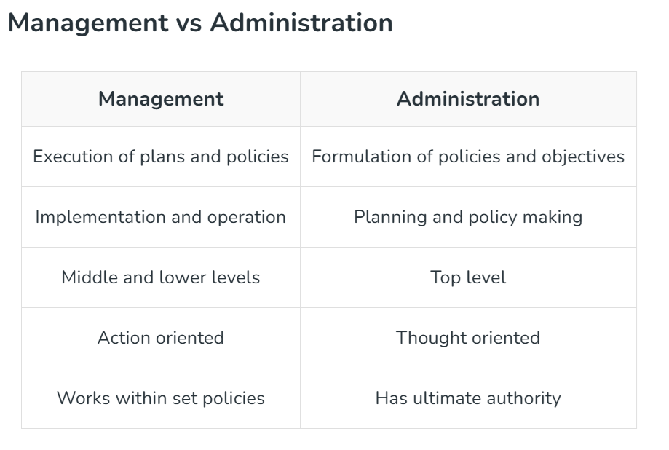

- Explain the levels of management.

Top-level Managers The top-level management is responsible for the overall activities of an organization. It establishes plans and goals that influence the entire organization.
- Top-level managers are few in number and occupy the posts of ‘Chief Executive Officer’, ‘Chairman’, ‘President’, ‘Vice-President’, ‘Director’ etc.

Middle-level Managers Middle-level managers are directly responsible for managing the performance of first-level managers.
- They are responsible for the operational efficiency of various departments in an organization and review daily and weekly reports on production or sales.
- They hold designations such as ‘Department Heads’, ‘Project Leader’, ‘Plant Manager’ and ‘Divisional Head.

First-level ManagersManagers at the first-level have the responsibility to manage the performance of the non-managerial personnel in an organization and ensure implementation of operational plans. They are also called Supervisors.
- They are given different titles in different companies like ‘Foreman’, Clerical Supervisor’, ‘Technical Supervisor’, etc.

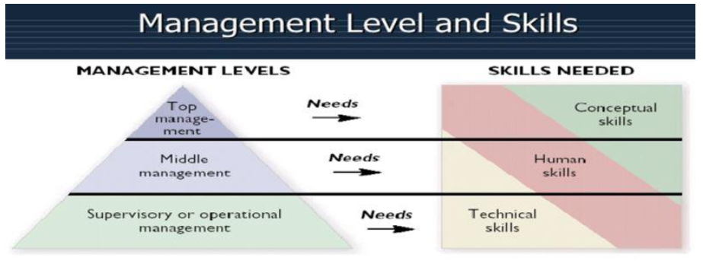

- Explain the Henry Fayol 14 principles of management.

Henri Fayol’s 14 Principles of Management:
- Division of Work: Specialization increases output by making employees more efficient.
- Authority and Responsibility: Managers must have the authority to give orders, balanced with responsibility for results.
- Discipline: Employees must obey and respect rules, as guided by effective leadership.
- Unity of Command: Each employee should receive orders from only one superior to avoid conflict.
- Unity of Direction: Activities with the same objective should be directed by one manager using one plan.
- Subordination of Individual Interest: The interests of the organization take precedence over personal interests.
- Remuneration: Fair pay is essential to motivate employees.
- Centralization: A proper balance between centralized authority and delegation (decentralization) is required.
- Scalar Chain: A clear, direct line of authority from top management to the lowest ranks.
- Order: Both material and social resources should be in the right place at the right time.
- Equity: Managers should treat employees with kindness and fairness.
- Stability of Tenure: High employee turnover should be avoided to ensure efficiency and stability.
- Initiative: Employees should be encouraged to create and carry out plans.
- Esprit de Corps: Promoting team spirit and harmony to build unity within the organization.

- Explain the Scientific management in evolution of management thought.

Scientific Management (F. W. Taylor)
- Scientific management means knowing exactly what you want men to do and seeing that they do it in best and cheapest way.
- It means conducting business activities according to standardized tools, methods and trained personnel in order to increase the output, improve its quality and reduce costs and waste.
- Frederick Winslow Taylor– Father of Scientific Management

Principles of Scientific Management:
1) Science, not rule of thumb
2) Harmony, not discord
3) Cooperation, not individualism
4) Development of workers to their greatest efficiency and Prosperity

Scientific Management is a key concept in the evolution of management thought, developed by Frederick Winslow Taylor in the late 19th and early 20th century. It marked the shift from traditional, rule-of-thumb methods to a more systematic and scientific approach to managing work.

Key Ideas of Scientific Management:
• Science, not Rule of Thumb
Replace traditional methods with scientific study to find the best way of performing each task.
• Harmony, not Discord
Promote cooperation and good relationships between workers and management instead of conflict.
• Cooperation, not Individualism
Management and workers should work together to achieve organizational goals.

• Development of Each Person to His/Her Greatest Efficiency and Prosperity
Select, train, and develop workers scientifically to maximize their potential and productivity.

Contribution to Management Thought:
- Introduced a systematic and logical approach to management.
- Improved efficiency and productivity in industries.
- Laid the foundation for modern management practices like operations management and industrial engineering.

Conclusion:
Scientific Management played a crucial role in the evolution of management by transforming it into a structured discipline based on scientific principles, making organizations more efficient and goal-oriented.

- Explain the Hawthorne experiments.
The Hawthorne experiments (1924–1932) at Western Electric’s Hawthorne Works, directed by Elton Mayo, found that worker productivity increased due to psychological and social factors—such as being observed and feeling valued—rather than just physical work conditions or financial incentives. This phenomenon is known as the "Hawthorne Effect".
Key Phases of the Experiments:
- Illumination Experiments (1924–1927): Researchers wanted to see if better lighting at work would increase productivity. They believed brighter light would make workers more efficient.
They divided workers into two groups:
- A test group, where lighting levels were changed
- A control group, where lighting stayed the same
What they found was surprising:
- When lighting was increased, both groups improved their productivity
- Even when lighting was reduced, both groups still improved
- Productivity only dropped when the light became as dim as moonlight (too low to work properly)
So, they concluded that lighting itself was not the main factor affecting productivity. Instead, something else was influencing workers.
They suspected that human factors (like attention, motivation, or feeling observed) were responsible, but they didn’t know exactly what. This led to further experiments to understand the real cause.
- Relay Assembly Test Room (1927): The Relay Assembly Test Room Experiments (1927–1929) were the next phase of studies to understand what really affects worker productivity.
- A small group of workers (usually 6 women) was chosen and placed in a separate room.
- They were asked to assemble telephone relays (small electrical devices).
- Researchers made changes to their working conditions, such as:
  - Work hours
  - Rest breaks
  - Wages and incentives
  - Work environment
Findings:
- Productivity kept increasing, even when conditions were not necessarily improved.
- Workers worked better because:
  - They felt special and important being part of the experiment
  - They received more attention and supervision
  - They developed a friendly and supportive group atmosphere
Hence, Productivity improved mainly due to social and psychological factors, not just physical conditions like lighting or breaks.
This led to the idea that Human relations, motivation, and attention play a major role in workplace performance.
- Mass Interview Programme (1928–1930): The Mass Interview Programme (1928–1930) was another phase of the Hawthorne studies, aimed at understanding workers’ feelings and attitudes.
- Researchers conducted thousands of interviews with workers.
- Workers were encouraged to talk freely about:
  - Their jobs
  - Supervisors
  - Working conditions
  - Personal problems
Findings:
- Workers’ productivity was strongly influenced by their emotions, attitudes, and feelings.
- Many workers were unhappy not because of physical conditions, but because they felt unheard or unimportant.
- Allowing workers to express themselves made them feel valued, which improved morale.
Conclusion:
Listening to employees and understanding their feelings is crucial for improving productivity.
Social and psychological factors matter more than just physical working conditions.

- Bank Wiring Observation Room (1931–1932):
  - A group of male workers was observed while doing wiring jobs.
  - No major changes were made in working conditions.
  - Researchers mainly studied group behavior.
Findings:
- Workers did not increase output even when incentives were offered.
- The group formed informal rules about how much work to do.
- Anyone who worked too fast or too slow was pressured by the group to match the standard.
- Workers preferred to keep output steady, not maximum.
Conclusion:
Group norms and peer pressure strongly influence individual performance.
Informal groups at work can control productivity more than incentives or management rules.

MODULE 2

- Define Organizational Behaviour and its nature.
Organizational Behavior (OB) is the systematic study of how individuals and groups act within organizations, aiming to improve company effectiveness and employee satisfaction.
Nature of Organizational Behavior:
A Separate Field of Study and Not a Discipline Only:By definition, a discipline is an accepted science that is based on a theoretical foundation. But, O.B. has a multi- interdisciplinary orientation and is, thus, not based on a specific theoretical background. Therefore, it is better reasonable to call O.B. a separate field of study rather than a discipline only.
An Interdisciplinary Approach:Organizational behaviour is essentially an interdisci­plinary approach to study human behaviour at work. It tries to integrate the relevant knowledge drawn from re­lated disciplines like psychology, sociology and anthro­pology to make them applicable for studying and analysing organizational behaviour.
An Applied Science:Organizational Behavior (OB) is considered an applied science because it uses theories, concepts, and principles from different disciplines to solve practical problems in organizations. Instead of only developing theoretical knowledge, OB focuses on applying that knowledge to improve organizational effectiveness and employee well-being.
A Normative Science:When OB is described as a normative science, it means that it does not only explain how people behave in organizations but also suggests how people should behave and how organizations ought to manage employees to achieve better outcomes.
A Humanistic and Optimistic Approach:Organizational Behaviour applies humanistic approach towards people working in the organization. It deals with the thinking and feeling of human beings. O.B. is based on the belief that people have an innate desire to be independent, creative and productive. It also realizes that people working in the organization can and will realize this potential if they are given proper conditions and environment. Environment affects performance or workers working in an organization.
A Total System Approach:The system approach is one that integrates all the variables, affecting organizational functioning. The systems approach has been developed by the behavioural scientists to analyse human behaviour in view of his/her socio-psychological framework. Man’s socio- psychological framework makes man a complex one and the systems approach tries to study his/her complexity and find solution to it.
- Explain the scope of Organizational behaviour.
Organizational Behaviour (OB) studies human behaviour in organizations and its impact on performance. Its scope includes:
- Individual Behaviour – Focuses on personality, perception, attitudes, and motivation of employees. It helps understand individual differences at work.
- Group Behaviour – Studies team dynamics, leadership, communication, and conflict management. It explains how people behave in groups.
- Organizational Structure – Deals with authority, responsibility, hierarchy, and job design to ensure efficient functioning.
- Organizational Culture – Refers to shared values and beliefs that influence employee behaviour and job satisfaction.
- Organizational Change and Development – Focuses on adapting to change, innovation, and improving organizational effectiveness.
Conclusion:
OB covers individual, group, and organizational aspects to improve productivity, employee satisfaction, and overall organizational effectiveness.
- List out the objectives of Organizational Behaviour.
Objective of Organizational Behavior:
There are several objectives of organisational behaviour and some of them are briefly stated here:
(i) To analyse different perspective and potentialities to create and develop the ethical values in an organisation,
(ii) To analyse the potentialities towards the ways and means to conduct and organise the systems, methods and approaches for organisation development in an organisation,
(iii) To analyse the potentialities to develop process, methods and approaches of formal and informal patterns of organisation and society,
(iv) To analyse how to make perspective methods and process of effective communication to formulate ethical norms in an organisation,
(v) To analyse various aspects and factors affecting the group cohesiveness
(vi) To analyse the ways and means to develop different ethical aspects for group dynamism,
(vii) To analyse the mutual interest of individual and group. Mutual interest is represented by the statement ‘Organisation needs people, and people also need organisation’,
(viii) To analyse and evaluate the role of different key elements like people, structure, technology interactive behaviour and environment etc.
(ix) To analyse and evaluate the behavioural approaches in organisation. In context of that all of them are based on ‘Art’ and ‘Science’.
(x) To analyse different aspects of work environment which duly affects the behavioural patterns and attitudes of persons.
4. Discuss the important of Organizational Behaviour.
Importance of Organizational Behavior:
- Creates Sustainable Competitive Advantage
Organizational Behavior helps organizations develop effective work culture, motivated employees, and efficient management practices. When employees perform better and work collaboratively, the organization gains a long-term competitive advantage over others.
- Individual Component
OB studies individual behavior at the workplace, including personality, perception, motivation, learning, and attitudes. Understanding these factors helps managers improve employee performance, job satisfaction, and productivity.
- Group / Team Component
Organizations rely on teamwork. OB explains how groups are formed, how team members interact, and how conflicts can be managed. It helps in building effective teams, better communication, and collaboration.
- Organizational Component
OB focuses on the overall structure, culture, policies, and work environment of an organization. A positive organizational culture improves coordination, efficiency, and employee commitment.
- Leadership Component
OB helps in understanding different leadership styles and their impact on employees. Effective leadership motivates employees, improves morale, and helps organizations achieve their goals successfully.
- External Forces Component
Organizations are influenced by external factors such as technology, economic conditions, social changes, and government policies. OB helps organizations adapt to these changes and manage their workforce effectively.
5. Explain the three basic units of analysis of Organizational Behaviour.
Organizational Behavior studies behavior in organizations at three main levels or units of analysis. These levels help managers understand how individuals and groups behave within an organization.
1. Individual Level
- Personality Traits: The various personality traits are of aid in estimating human behavior. For example, conscientiousness and emotional stability can be meaningful in predicting employee performance in some jobs.
- Motivation: Motivational theories like Maslow’s Hierarchy of Needs or Herzberg’s Two-Factor Theory can provide us with a good idea of what encourages an employee to perform. This information helps managers create incentive plans that resonate with the things people naturally value in their work, as well as aligning those efforts to more tangible rewards.
- Perception: Employees’ perceptions affect how they interpret and respond to workplace events. Cognitive biases and selective perception can influence their decision-making and interactions with colleagues.
- Learning: Learning theories explain how employees acquire and apply new skills and knowledge. Understanding these processes can help organizations develop effective training programs.
- Decision-Making: Analyzing individual decision-making processes reveals how employees choose among alternatives and the potential biases that might affect their choices.
2. Group Level
- Group Composition: The mix of skills, personalities, and roles within a team affects its performance. Diverse teams can bring varied perspectives, but they also require effective management to prevent conflicts.
- Communication Patterns: Effective communication is crucial for group success. Understanding how information flows within a team and identifying any communication barriers can improve collaboration.
- Leadership Styles: Different leadership styles, such as transformational or transactional leadership, impact group dynamics and performance. Effective leaders can inspire and guide their teams to achieve common goals.
- Group Norms: These are the unwritten rules that govern behavior within a group. Norms influence how team members interact and perform.
- Cohesiveness: The degree to which group members bond and work well together affects the group’s productivity and morale. High cohesiveness often leads to better teamwork, but can also result in groupthink if not managed properly
3. Organizational Level
- Organizational Culture: The shared values, beliefs, and norms within an organization shape employees’ behaviors and attitudes. A strong, positive culture can enhance employee engagement and loyalty.
- Organizational Structure: The way an organization is structured, including its hierarchy, roles, and responsibilities, affects how work is coordinated and executed.
- Systems and Processes: These include formal procedures and informal practices that guide how tasks are performed and decisions are made.
- Leadership Styles: At the organizational level, leadership influences the overall direction and vision of the company. Effective leadership can drive organizational change and foster a positive work environment.
- Change Management: Understanding the dynamics of change within an organization helps in managing transitions smoothly and maintaining employee morale during periods of change.
- External Factors: Factors such as market conditions, competition, and regulatory environment impact organizational behavior and performance.

6. Discuss the elements of Organizational Behaviour.
Key Elements of Organizational Behaviour
Organizational Behaviour (OB) is influenced by four key elements that interact with each other to shape employee behaviour and organizational performance:

1. People
People are the most important element of any organization. They include individuals and groups working within the organization.
- Individuals bring their own personality, attitudes, perceptions, and skills.
- Groups influence behaviour through teamwork, communication, and leadership.
👉 Effective management of people leads to higher motivation, satisfaction, and productivity.

2. Structure
Structure defines how tasks and responsibilities are divided and coordinated.
- It includes hierarchy, authority, roles, and relationships.
- A well-designed structure ensures clarity in duties and smooth workflow.
👉 Proper structure helps in achieving organizational goals efficiently.

3. Technology
Technology refers to the tools, machines, and methods used to perform work.
- It determines how work is done and how people interact.
- Advanced technology can improve efficiency but may require new skills.
👉 Technology influences job design, productivity, and employee satisfaction.

4. Environment
Environment includes all external factors that affect the organization.
- Economic conditions, government policies, social and cultural factors, and competition.
- Organizations must adapt to environmental changes to survive and grow.
👉 A dynamic environment requires flexibility and innovation.

Conclusion:
Organizational Behaviour is the result of the interaction between people, structure, technology, and environment. Understanding these elements helps managers improve performance, employee satisfaction, and overall organizational effectiveness.
- Explain the intuition and systematic study in Organizational Behaviour.
1. Intuition
Intuition refers to making decisions based on personal feelings, experience, instincts, or judgment rather than scientific evidence.
Characteristics:
- Based on personal experience
- Quick decision-making
- Influenced by emotions and beliefs
- Not always accurate or reliable
Example:
A manager believes that a particular employee will perform well in a leadership role simply because the manager feels the employee is capable.
2. Systematic Study
Systematic study means analyzingbehavior using scientific methods, research, and data. It involves observing, collecting information, and identifying patterns to understand behavior.
Characteristics:
- Based on research and evidence
- Uses data and analysis
- More objective and reliable
- Helps predict behavior accurately

Example:
A company studies employee performance data and feedback before promoting someone to a managerial position.
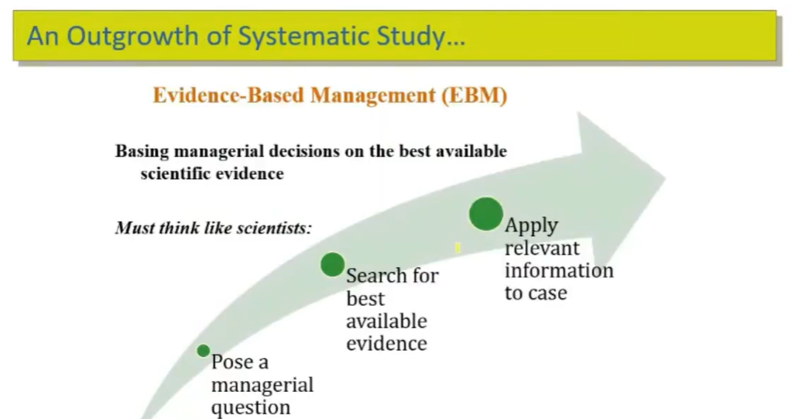
Difference Between Intuition and Systematic Study
Basis | Intuition | Systematic Study
Meaning | Based on personal feelings and experience | Based on research and scientific methods
Accuracy | May be subjective and less reliable | More objective and reliable
Decision-making | Quick and instinctive | Logical and data-based

- List out the challenges of Organizational Behaviour.
Challenges for Organisational Behaviour
Organisational Behaviour faces numerous challenges that are constantly evolving to improve efficiency and achieve business goals. While the nature of jobs changes, some problems persist.
1. Lack of Clear Direction: Leaders may either seldom discuss or outline a deliberate future direction or strategy, or they may fail to communicate a coherent message about this strategy to all organisation members. Organisations often have numerous activities to carry out but lack the synchronisation needed to generate the momentum necessary for the organisation to modify, adapt, and shape its future.
2. Integrating Multiple Personalities: The difficulty of integrating multiple personalities into a cohesive and unified team is a significant challenge. The mix of backgrounds, judgements, views, and experiences can pose challenges for teams trying to come together and work harmoniously.
3. Development of Key Capabilities and Behaviours: Despite the presence of many hardworking individuals with good intentions in any organisation, creating a high-performance organisation often remains elusive.
4. Poor Communication and Feedback: Challenges arise when people either do everything possible to avoid confronting others and holding them accountable, or seize any opportunity to berate people, belittlethem, and crush their spirits.
5. Absence of Perception: Building a viable organisation requires hard work and a keen understanding of the culture and environment that exist in a business. A clear understanding of market requirements and market forecasts is essential. The absence of these can result in significant losses in every sector.
6. Turnover: This is all about how frequently people leave a company and need to be replaced. A high turnover rate can often be traced back to the work environment or the style of leadership. This situation demands recruiters invest more time and resources in the hiring process. Companies need to focus on keeping their employees satisfied, as this helps in retaining talented professionals and attracting suitable candidates for open positions.
7. Productivity Issues: This challenge comes into play when there is a lack of motivation among the staff, leading to a reluctance to fulfil their job responsibilities. This can slow down the company’s operations and make it more difficult to achieve set goals. Productive employees have a clear understanding of what’s expected of them, and they put in the effort to meet these expectations.
8. Limited Innovation: This refers to a company’s struggle to come up with new ideas and get ahead of its competitors. This can also have an impact on employee motivation. Employees who are not passionate about their roles may not feel driven to perform them. As time passes, a company should change its approach. Shaking things up in the workplace can lead to the emergence of fresh ideas and reignite passion among employees.
9. Dealing with Workplace Conflicts: In any organisation, conflicts can emerge due to varying opinions, personalities, attitudes, and objectives. Such conflicts can hamper teamwork, lower productivity, and decrease employee satisfaction. However, by establishing a conflict resolution process and offering conflict management training, these conflicts can be effectively managed.
10. Clarifying Roles and Responsibilities: Non-clarity in roles and responsibilities can lead to confusion and inefficiencies among individuals, resulting in errors and overlapping tasks. It is crucial to clearly outline each person’s roles and responsibilities. Additionally, establishing effective communication channels can help in seeking clarification and avoiding misunderstandings.

MODULE 3

  - Define Perception and perceptual process.
- Perception in organizational behaviour refers to the process through which individuals interpret and make sense of their environment, including people, events, and situations within the workplace.
- It involves selecting, organizing, and interpreting sensory information to form mental representations or perceptions.
Perceptual Process:
- Understanding perception in organizational behaviour helps managers and leaders create a more effective and supportive work environment by addressing and mitigating the factors that lead to misperceptions and enhancing those that contribute to accurate perceptions.
- The significance of perception in organizational behaviour is underscored by its profound impact on how employees perceive and respond to various organizational dynamics. It is a key determinant of their motivation, job satisfaction, and interaction with others, thereby playing a pivotal role in shaping organizational effectiveness and culture.
Selection
- Individuals selectively attend to certain stimuli in their environment while ignoring others based on factors such as relevance, salience, and familiarity. In the workplace, employees may prioritize information related to their job responsibilities, goals, and interests.

Organization
- Selected stimuli are organized and categorized into meaningful patterns or schemas based on pre-existing knowledge, experiences, and cultural norms.
- For example, employees may categorize colleagues as friendly or competitive based on past interactions and social cues.
Interpretation
- Organized stimuli are interpreted or assigned meaning based on individual perceptions, attributions, and cognitive biases. Interpretations may vary depending on factors such as personality, values, beliefs, and situational context.
- For instance, an ambiguous performance review may be perceived as constructive feedback by one employee and as criticism by another.
Integration
- Finally, perceptions are integrated into cognitive structures or mental representations that guide behaviour and decision-making. Integrated perceptions influence how individuals respond to challenges, conflicts, and opportunities within the organization, shaping their attitudes, motivations, and interpersonal relationships.

- Define Perceptual distortion and types.

- Perceptual distortion refers to errors or biases in perceiving and interpreting information about people, situations, or events.
- It occurs when individuals misinterpret reality due to personal beliefs, experiences, attitudes, or expectations. In organizations, perceptual distortions can affect decision-making, communication, performance evaluation, and interpersonal relationships.

Types of Perceptual Distortion
1. Stereotyping
Stereotyping occurs when a person judges someone based on the group they belong to rather than their individual qualities.
Example:
Assuming that younger employees are irresponsible or that older employees resist technology.
2. Halo Effect
The halo effect happens when one positive trait of a person influences the overall perception of that individual.
Example:
If an employee is very polite, a manager may assume the employee is also highly competent even without evidence.
3. Horn Effect
The horn effect is the opposite of the halo effect, where one negative trait leads to a negative overall impression of a person.
Example:
If an employee makes one mistake, the manager may assume that the employee is generally incompetent.
4. Selective Perception
Selective perception occurs when people notice only the information that supports their beliefs and ignore contradictory information.
Example:
A manager who believes a particular employee is inefficient may only notice their mistakes and ignore their achievements.
5. Projection
Projection occurs when individuals attribute their own feelings, motives, or characteristics to others.
Example:
A manager who is very competitive may assume that all employees are equally competitive.
6. Attribution Error
This occurs when people incorrectly judge the causes of others’ behavior.
Example:
If an employee performs poorly, the manager may assume the employee is careless rather than considering external factors such as workload or lack of resources.
7. Recency Effect
The recency effect occurs when recent events influence a person’s judgment more strongly than earlier events.
Example:
During performance appraisal, a manager may evaluate an employee mainly based on their most recent performance.

- Define Attribution and its types
Attribution refers to the process by which individuals interpret and explain the causes of behavior or events. It helps people understand why someone behaved in a particular way.
Types of Attributions
1. Internal Attribution (Dispositional Attribution)
Internal attribution occurs when behavior is explained by personal factors within the individual.
These factors include:
- Ability
- Effort
- Skills
- Personality
- Motivation
- Attitude
Example:
A manager believes an employee succeeded because they are hardworking and talented.
2. External Attribution (Situational Attribution)
External attribution occurs when behavior is explained by factors outside the individual.
These factors include:
- Work environment
- Task difficulty
- Luck
- Organizational policies
- Support from colleagues
Example:
A manager believes an employee failed to complete work because the task was too difficult or resources were insufficient.
3. Stable Attribution
Stable attribution refers to causes of behavior that are permanent and remain consistent over time. These factors do not change easily and influence behavior repeatedly.
Examples of Stable Factors:
- Ability or talent
- Personality traits
- Intelligence
- Long-term attitudes
Example:
If a manager believes an employee performs well because of high ability or strong skills, this is a stable attribution since ability is considered relatively constant.
4. Unstable Attribution
Unstable attribution refers to causes of behavior that are temporary and can change over time. These factors may vary depending on the situation.
Examples of Unstable Factors:
- Effort
- Mood
- Luck
- Temporary health issues
- Situational pressure
Example:
If a manager thinks an employee succeeded because of good luck or extra effort on that day, this is an unstable attribution.

5. Controllable Attribution
Controllable attribution refers to causes of behavior that a person can control or influence through their actions or effort.
These factors depend on individual choices, effort, and behavior.
Examples of Controllable Factors:
- Effort
- Hard work
- Preparation
- Time management
- Skill improvement
Example:
If a student fails an exam because they did not study enough, the cause is controllable because the student could have studied more.
6. Uncontrollable Attribution
Uncontrollable attribution refers to causes of behavior that a person cannot control. These factors are outside the individual’s influence.
Examples of Uncontrollable Factors:
- Luck
- Natural ability
- Illness
- Economic conditions
- Unexpected situations
Example:
If an employee misses work because of sudden illness, the cause is uncontrollable.

- Explain Attribution theory.
Attribution Theory:
- Attribution theory is a theory about how people explain things. It seeks to explain how and why people make these causal attributions.
Core Concepts of Attribution Theory
Locus of Control: This concept revolves around whether the cause of an event is perceived to be internal or external. An internal locus of control means the person believes they can influence events and their outcomes, while an external locus of control suggests that external forces dictate events.
Stability: Stability refers to whether the cause of an event is seen as stable or unstable over time. Stable causes are seen as permanent (e.g., natural ability), whereas unstable causes are temporary (e.g., mood).
Controllability: This concept deals with whether the cause of an event is something that can be controlled. For instance, effort is a controllable factor, while innate ability is not.
Key models with Attribution Theory:
1) Heider’s Naive Psychology:
  - Fritz Heider, often considered the father of Attribution Theory.
  - He proposed that people are intuitive psychologists who try to make sense of the world by attributing causes to behavior.
Types of Causes (Attributions)
1. Internal Causes (Personal Factors)
- Behavior is due to individual traits
- Includes ability, effort, mood, personality
Example:
“She scored high because she is intelligent.”
2. External Causes (Situational Factors)
- Behavior is due to outside conditions
- Includes luck, environment, task difficulty
Example:
“He failed because the exam was tough.”
Overall Example:
A worker completes a project successfully:
- Internal attribution: “He is skilled and hardworking”
- External attribution: “He got good team support”

2) Kelley’s Covariation Model: Harold Kelley introduced the covariation model, which suggests that people make attributions by considering three types of information: consistency, distinctiveness, and consensus.
a) Consensus
Consensus refers to whether other people behave in the same way in similar situations.
- High consensus: Many people behave the same way.
- Low consensus: Only one person behaves that way.
Example:
If many employees miss a deadline, the problem may be external (task difficulty).
b) Consistency
Consistency refers to whether the person behaves the same way over time.
- High consistency: Behavior occurs repeatedly.
- Low consistency: Behavior occurs only occasionally.
Example:
If an employee is always late, it may be due to personal habits (internal).
c) Distinctiveness
Distinctiveness refers to whether a person behaves differently in different situations.
- High distinctiveness: Behavior occurs only in a specific situation.
- Low distinctiveness: Behavior occurs in many situations.
Example:
If an employee performs poorly only in one task but well in others, the cause may be external.
3) Weiner’s Attribution Theory of Motivation and Emotion:
Bernard Weiner expanded Attribution Theory by linking it to motivation and emotion. He proposed that attributions influence emotions and subsequent behaviors.
For example, attributing failure to a lack of effort (an internal, controllable cause) might lead to feelings of guilt and a motivation to work harder, whereas attributing it to bad luck (an external, uncontrollable cause) might lead to feelings of helplessness and reduced motivation.
Three dimensions:
- Locus (internal/external)
- Stability (stable/unstable)
- Controllability (controllable/uncontrollable)

